# **Biology – ATAR Year 12**

## **Unit 4 TEST**

## **TASK 8: HOMEOSTASIS**

Time for the task: 50 minutes

____________________________________________________________________________

**Section A – Multiple-choice questions (20 marks)**

**Choose the best answer from those given and mark your answer on the multiple choice answer sheet on the front of the test answer booklet.**

1. Homeostasis is an example of which of the following characteristics of life?
2. Metabolism
3. Responsiveness
4. Growth
5. Regulation
6. Receptors are an important part of the homeostatic mechanism. The function of a receptor is to;
   1. Interpret information received from its environment and sends it to the modulator.
   2. Receive information and communicate with the modulator or transmitter.
   3. Respond to a stimulus from the effector.
   4. Create a stimulus which is sent to the effector.
7. For animals living in freshwater excretion of water is a necessity because;
   1. their cells cannot retain high concentrations of water.
   2. water will always go from a high concentration of salts to a lower concentration.
   3. water in the external environment has a higher concentration of dissolved salts than what is found inside their cells.
   4. their body cells naturally gain water because of their relatively high salt concentration.
8. Which of the following correctly matches the state of the guard cells to the opening or closing of the stomatal pores?
   1. If guard cells are flaccid, stomatal pores are kept open.
   2. If the osmotic pressure in guard cells is higher than the surrounding epidermal cells then stomatal pores will be open.
   3. If the osmotic pressure in guard cells is lower than the surrounding epidermal cells then stomatal pores will be open.
   4. If guard cells are turgid, stomatal pores are kept closed.
9. Which of the following behaviour patterns is least expected in a desert animal?
   1. Feeding in the daytime
   2. Resting in burrows
   3. Eating insects
   4. Becoming inactive in the hotter, drier months

**The following table indicates daily heat losses by a human adult in a temperate climate**

|  |  |
| --- | --- |
| **Method of heat loss** | **Amount (kilojoules)** |
| Conduction/radiation | 7700 |
| Evaporation of water from skin | 1800 |
| Evaporation of water from lungs | 800 |
| warming air in lungs | 300 |
| urine/faeces | 200 |
| **Total daily loss** | **10 800kJ** |

1. Which method shown in the above table would increase the most if the air temperature was to rise?
   1. Conduction and radiation
   2. Evaporation from the skin
   3. Evaporation from the lungs
   4. Urine and faeces

The graph below shows the rate of oxygen consumption of a marsupial at different air temperatures.

1. The data graphed above indicates that
   1. a high rate of oxygen consumption can cause a rise in body temperature.
   2. the marsupial cannot survive at air temperatures lower than 10oC.
   3. in cold weather marsupials reduce the energy they use.
   4. energy is used up by the marsupial to maintain a constant body temperature.

Questions 8 and 9 refer to the table presented below. It contains experimental data collected during an investigation.

Growth of Plants (cm)

|  |  |  |  |
| --- | --- | --- | --- |
| Salt Levels  (g/L) | One Month | Two Months | Three Months |
| 10 | 4.0 | 5.5 | 7.8 |
| 25 | 3.3 | 4.4 | 2.2 |
| 35 | 1.0 | 0.5 | 0 |

1. The best way to control the variables for this experiment would be to
2. a plant grown in distilled water.
3. repeating this investigation many times.
4. making sure that all the plants were given identical soil, light and temperature.
5. planning to use only one species type.
6. This data is
7. discontinuous and best represented as a histogram.
8. discontinuous and best represented as a line graph.
9. continuous and best represented as a line graph.
10. continuous and best represented as a scatter diagram.
11. Many desert plants have leaf adaptations that enable them to survive dry, hot conditions. Which of these adaptations would limit gas exchange most markedly?
12. A thick, waxy cuticle.
13. A reduced number of stomata.
14. Leaf hairs.
15. Stomata that open at night.
16. The Mohave ground squirrel, unlike the antelope ground squirrel, spends seven of the driest months, from August to March, in an inactive state in its burrow. From March to August, when conditions are more favourable, it becomes active again, coming up to feed in the daytime. During these five months the squirrels put on weight and store fat in their bodies. The advantage of this period of inactivity to the Mohave ground squirrel is that it
    1. helps it to conserve energy.
    2. helps it to conserve water.
    3. reduces competition with the antelope ground squirrel.
    4. all of the above.

The body temperature of two different mammals was recorded over 24 hours. The average daytime temperature was 40oC and average night-time temperature was 20oC. The temperatures of the mammals over the 24 hours are shown in the graph below. Use this information to answer questions 12 and 13.

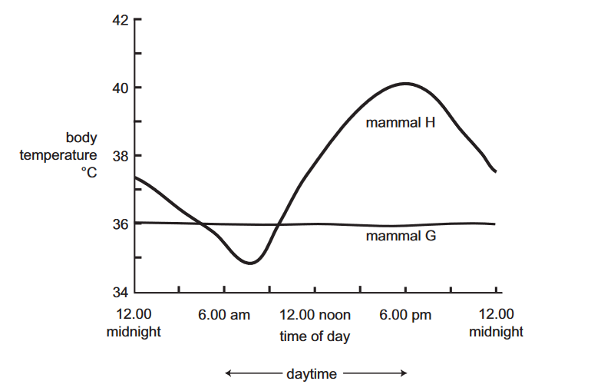

1. From the information given in the graph, it would be reasonable to conclude that
   * 1. between midnight and 6.00 am, mammal H would be gaining heat by conduction.
2. at 12.00 noon, mammal H would be gaining heat by radiation.
3. at 12.00 noon, mammal G is losing heat by radiation.
4. between midnight and 6.00 am, mammal G would be losing heat through evaporation of sweat.
5. Mammals that live in very cold environments have behavioural adaptations that help reduce the rate at which they lose heat. One behavioural adaptation could be
6. decreasing food intake.
7. having fur that fluffs out.
8. curling up into the shape of a ball.
9. isolating themselves from other individuals.
10. The Arctic Fox has a thick fur coat. The fur traps a layer of air close to the body of the fox and reduces heat loss by

(a) evaporation.

(b) conduction.

(c) radiation.

(d) convection.

1. Which of the following statements about nitrogenous waste is correct?

(a) Ammonia is more toxic than uric acid.

(b) Uric acid is more soluble in water than urea.

(c) It takes more energy to produce urea than uric acid.

(d) It takes more water to excrete urea than ammonia.

1. Birds are

(a) endothermic and excrete nitrogenous waste as urea.

(b) endothermic and excrete nitrogenous waste as uric acid.

(c) ectothermic and excrete nitrogenous waste as urea.

(d) ectothermic and excrete nitrogenous waste as uric acid.

1. A plant that is adapted to a cool, moist environment is most likely to have leaves

(a) with many stomata.

(b) with a thick cuticle.

(c) that are reduced to spikes.

(d) that are covered in hairs.

1. 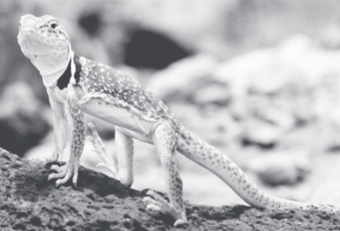In the hottest parts of the day, lizards stand so that their bodies do not touch the rocks they are standing on.

This assists the lizards to

(a) increase heat loss by convection and conduction.

(b) decrease heat gain by convection and conduction.

(c) decrease heat gain by convection and increase heat loss by conduction.

(d) increase heat loss by convection and decrease heat gain by conduction.

1. Which of the following statements about homeostatic control mechanisms is correct?
   * 1. Negative feedback mechanisms are common and reduce the original stimulus.
     2. Negative feedback mechanisms are common and enhance the original stimulus.
     3. Positive feedback mechanisms are common and enhance the original stimulus.
     4. Positive feedback mechanisms are common and reduce the original stimulus.
2. Part of a sequence of steps that occur after an increase in the levels of carbon dioxide in the blood of a mammal is shown in the diagram below.



This sequence is an example of

* 1. Positive feedback, as it involves the autonomic nervous system
  2. Positive feedback, as it involves an increase in the levels of carbon dioxide
  3. Negative feedback, as it involves changes in the carbon dioxide levels and breathing rate
  4. Negative feedback, as it involves an effect that is opposite to the stimulus

**END OF SECTION A**

**Year 12 Biology Unit 4**

**TASK 8: Homeostasis TEST**

**RESULT**

TIME ALLOWED: 50 MINUTES

**NAME_________________________________**

**Section A – Multiple-choice answers (20 marks)**

**Mark your answers on the grid below using PENCIL.**

|  |  |  |  |  |  |  |  |  |  |  |
| --- | --- | --- | --- | --- | --- | --- | --- | --- | --- | --- |
| **Question** |  | | | |  | **Question** |  | | | |
| **1** | **A** | **B** | **C** | **D** |  | **11** | **A** | **B** | **C** | **D** |
| **2** | **A** | **B** | **C** | **D** |  | **12** | **A** | **B** | **C** | **D** |
| **3** | **A** | **B** | **C** | **D** |  | **13** | **A** | **B** | **C** | **D** |
| **4** | **A** | **B** | **C** | **D** |  | **14** | **A** | **B** | **C** | **D** |
| **5** | **A** | **B** | **C** | **D** |  | **15** | **A** | **B** | **C** | **D** |
| **6** | **A** | **B** | **C** | **D** |  | **16** | **A** | **B** | **C** | **D** |
| **7** | **A** | **B** | **C** | **D** |  | **17** | **A** | **B** | **C** | **D** |
| **8** | **A** | **B** | **C** | **D** |  | **18** | **A** | **B** | **C** | **D** |
| **9** | **A** | **B** | **C** | **D** |  | **19** | **A** | **B** | **C** | **D** |
| **10** | **A** | **B** | **C** | **D** |  | **20** | **A** | **B** | **C** | **D** |

**Section B – Short answer Name_____________________________ (30 marks)**

**Write your answers in the space provided.**

**Question 21 (10 marks)**

The homeostasis of the internal environment is a major requirement of all living organisms.

State why the following conditions must be controlled by the process of homeostasis for the effective functioning of the organism.

* + - 1. Carbon dioxide (2 marks)

***Too much CO2 lowers the pH levels in the blood (1)***

***This can cause enzymes to denature / interfere with cell functioning (1)***

2. Salt (2 marks)

***Excess or too little salt affects the water balance / osmotic affect (1)***

***Lack of salt will cause metabolic disorders as it is necessary for diet (1)***

***Salt is needed for certain functions in the body such as nerve transmission(1)***

Marine and freshwater fish balance the loss and gain of salt and water using different mechanisms depending on their environment.

3. Complete the table below to compare the processes that fish use to maintain water and salt balance. (6 marks)

|  |  |  |
| --- | --- | --- |
|  | Freshwater | Salt water |
| Gills | ***Actively absorbs salt into blood*** | ***Excretes salt out of blood*** |
| Urine | ***Large volume (1/2)***  ***Dilute urine (1/2)*** | ***Small volume (1/2)***  ***Concentrated urine (1/2)*** |
| Drinking | ***Does not need to drink*** | ***Drinks sea water*** |

**Question 22 (5 marks)**

A student collected leaves from different plants from different environments. On her way back to the laboratory the labels on the specimens came off. She took cross sections (drawn below) of some of the leaves and looked at them under a microscope.

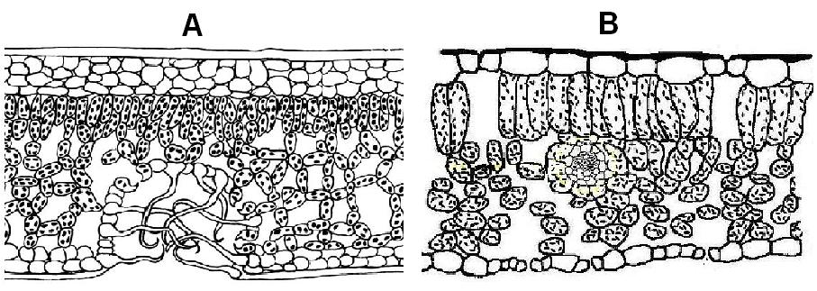

Diagram A - [Bgqhrsnog](http://commons.wikimedia.org/wiki/User:Bgqhrsnog) (2006) *Cross section through a xerophyte leave.* <http://commons.wikimedia.org/wiki/File:Xerophyten_-_Blattanatomie.png>. Accessed 5 October, 2009

# Diagram B - [Maksim](http://commons.wikimedia.org/wiki/User:Maksim) (2006) *File:Blad dwarsdoorsnede.jpg.* <http://commons.wikimedia.org/wiki/File:Blad_dwarsdoorsnede.jpg>. Accessed 5 October 2008

# Which plant is adapted to survive in arid conditions? (1 mark)

***Plant A***

__________________________________________________________________________________________________________________________________________________________________

* 1. Briefly describe **two** adaptations evident in this leaf cross section that support this inference. (2 marks)

***Stomata are in a pit / sunken***

***Stomata are on underside of leaf***

***Leaf hairs around stomata***

***Thick cuticle ( any two)***

* 1. Describe a **physiological** adaptation of an arid climate plant: (2 marks)

***Stomata close when water is insufficient / during hot parts of the day (1)***

***OR Stomata open during cooler parts of the day when water is sufficient (1)***

***This reduces the water loss from evaporation inside the leaf (1)***

**Question 23 (4 marks)**

A halophyte is a plant that can survive in a saline environment.

1. **Describe** **two** structural adaptations of halophytes **and explain** how each adaptation allows the plant to survive. (2 marks)

***Large vacuoles that store salt, so salt is reduced in the cell***

***Pneumatophores are special vertical roots that enable the roots to breathe when underwater***

***Specialised glands on the surface of leaves that excrete excess salt***

***Specialised tissue on their roots that reduce the salt intake at the roots***

***Buttress roots that keep tree stable when submerged ( any two)***

1. Some halophytes are salt accumulators. Explain how the accumulation of salts allows the halophyte to maintain water balance. (2 marks)

***The*** ***accumulation of salts - reverses the osmotic gradiant / increases the solute concentration (1)***

***So water will still be able to move into the plant for normal cell functioning despite living in a salty environment (1)***

**Question 24 (3 marks)**

Weddell seals, as shown in the diagram below, are diving mammals that live in cold environment

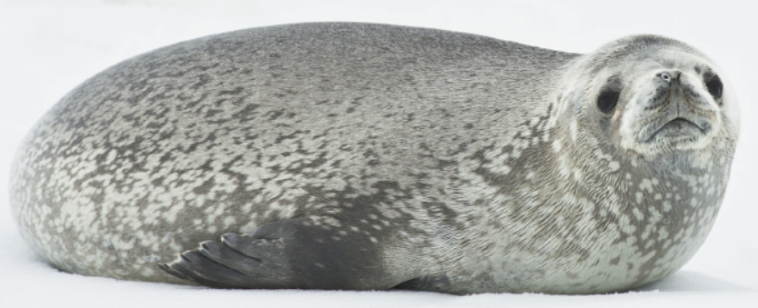

Explain how the Weddell seal is adapted to living in a cold environment. (3 marks)

***Thick layer of blubber / fat which reduces heat loss by conduction / acts as an insulator***

***Large round shape which reduces the Surface Area : Volume ratio so minimizing heat loss.***

***Dark skin colour absorbs heat radiation, Black flippers absorb heat radiation. Lies on beach to***

***absorb heat. Raises black flippers when swimming on back to absorb heat from sun.***

***Counter current heat exchange in blood of flippers to minimize heat loss. ( ANY 3)***

***Only accept FUR COAT if students say the young have it, as Adults lose it and have skin only***

**Question 25**  **(8 marks)**

The following question’s focus is the Desert Scorpion. The Desert Scorpion, which is found in Arizona (United States of America), was studied by Neil Hadley from the Arizona State University. Scorpions are classified into the phylum Arthropoda.

Hadley researched the total water-loss rates for live scorpions in dry air at progressively higher temperatures. Mean hourly rates were calculated from weight changes after the scorpions were exposed to six hours at each temperature. All scorpions survived the temperatures, except at 44 °C where approximately 25% mortality occurred after six hours. Data from dead scorpions are included.

**Table 1: The relationship between environmental temperature,   
percentage weight loss and metabolic rate in Desert Scorpions**

|  |  |  |
| --- | --- | --- |
| Temperature (°C) | % weight lost/hour | Microlitres of O2 consumed/g/hour |
| 25 | 0.021 | 70 |
| 30 | 0.028 | 82 |
| 35 | 0.035 | 101 |
| 38 | 0.040 | not recorded |
| 40 | 0.137 | 140 |
| 43 | 0.701 | 253 |
| 44 | 1.302 | 498 |

*This question continues on the next page.*

***Marks for graph***

***1 title – must have the two variables and their relationship***

***1 labels on the axis correct, including units***

***1 Correct Plotting ( line joining dots) and the interpolation shown from 35-40 degrees***

***1 Neatness and size of graph appropriate***

***NOTE - DEDUCT 2 MARKS IF BAR GRAPH OR IF TEMPERATURE IS ON WRONG SIDE***

1. Produce a graph to show the relationship between temperature and oxygen consumption. (4 marks)

|  |  |  |  |  |  |  |  |  |  |  |  |  |  |  |  |  |  |  |  |  |  |  |  |  |
| --- | --- | --- | --- | --- | --- | --- | --- | --- | --- | --- | --- | --- | --- | --- | --- | --- | --- | --- | --- | --- | --- | --- | --- | --- |
|  |  |  |  |  |  |  |  |  |  |  |  |  |  |  |  |  |  |  |  |  |  |  |  |  |
|  |  |  |  |  |  |  |  |  |  |  |  |  |  |  |  |  |  |  |  |  |  |  |  |  |
|  |  |  |  |  |  |  |  |  |  |  |  |  |  |  |  |  |  |  |  |  |  |  |  |  |
|  |  |  |  |  |  |  |  |  |  |  |  |  |  |  |  |  |  |  |  |  |  |  |  |  |
|  |  |  |  |  |  |  |  |  |  |  |  |  |  |  |  |  |  |  |  |  |  |  |  |  |
|  |  |  |  |  |  |  |  |  |  |  |  |  |  |  |  |  |  |  |  |  |  |  |  |  |
|  |  |  |  |  |  |  |  |  |  |  |  |  |  |  |  |  |  |  |  |  |  |  |  |  |
|  |  |  |  |  |  |  |  |  |  |  |  |  |  |  |  |  |  |  |  |  |  |  |  |  |
|  |  |  |  |  |  |  |  |  |  |  |  |  |  |  |  |  |  |  |  |  |  |  |  |  |
|  |  |  |  |  |  |  |  |  |  |  |  |  |  |  |  |  |  |  |  |  |  |  |  |  |
|  |  |  |  |  |  |  |  |  |  |  |  |  |  |  |  |  |  |  |  |  |  |  |  |  |
|  |  |  |  |  |  |  |  |  |  |  |  |  |  |  |  |  |  |  |  |  |  |  |  |  |
|  |  |  |  |  |  |  |  |  |  |  |  |  |  |  |  |  |  |  |  |  |  |  |  |  |
|  |  |  |  |  |  |  |  |  |  |  |  |  |  |  |  |  |  |  |  |  |  |  |  |  |
|  |  |  |  |  |  |  |  |  |  |  |  |  |  |  |  |  |  |  |  |  |  |  |  |  |
|  |  |  |  |  |  |  |  |  |  |  |  |  |  |  |  |  |  |  |  |  |  |  |  |  |
|  |  |  |  |  |  |  |  |  |  |  |  |  |  |  |  |  |  |  |  |  |  |  |  |  |
|  |  |  |  |  |  |  |  |  |  |  |  |  |  |  |  |  |  |  |  |  |  |  |  |  |
|  |  |  |  |  |  |  |  |  |  |  |  |  |  |  |  |  |  |  |  |  |  |  |  |  |
|  |  |  |  |  |  |  |  |  |  |  |  |  |  |  |  |  |  |  |  |  |  |  |  |  |
|  |  |  |  |  |  |  |  |  |  |  |  |  |  |  |  |  |  |  |  |  |  |  |  |  |
|  |  |  |  |  |  |  |  |  |  |  |  |  |  |  |  |  |  |  |  |  |  |  |  |  |
|  |  |  |  |  |  |  |  |  |  |  |  |  |  |  |  |  |  |  |  |  |  |  |  |  |
|  |  |  |  |  |  |  |  |  |  |  |  |  |  |  |  |  |  |  |  |  |  |  |  |  |
|  |  |  |  |  |  |  |  |  |  |  |  |  |  |  |  |  |  |  |  |  |  |  |  |  |
|  |  |  |  |  |  |  |  |  |  |  |  |  |  |  |  |  |  |  |  |  |  |  |  |  |
|  |  |  |  |  |  |  |  |  |  |  |  |  |  |  |  |  |  |  |  |  |  |  |  |  |
|  |  |  |  |  |  |  |  |  |  |  |  |  |  |  |  |  |  |  |  |  |  |  |  |  |

1. State the relationship between environmental temperature and metabolic rate for the Desert Scorpion. Provide an explanation for this. (2 marks)

***As the temperature increases so does their metabolic rate / oxygen consumption particularly after 40 degrees (1)***

***Scorpions are ectotherms and they gain their energy from their surroundings (1)***

1. Using your knowledge of temperature regulation, predict the most likely way for a Desert Scorpion to maintain its body temperature when its natural environment gets very hot. Provide a supporting explanation as to why this is likely. (2 marks)

**The scorpion would move to the shade / go down its burrow (1)**

**A scorpion - cannot sweat or pant / relies on its behavior for temperature regulation (1)**

**END OF TEST**